Use Case Diagram : We all know Its a Behavior Model and Its the Relation between user aka (as known as) Primary ACTOR and Administrator aka Secondary Actor.

One of the most useful Diagram in Software Engineering.

We Will take One Scenario i.e "BOOK STORE AT SHOPPING MALL"

lets discuss the situation before making Use - Case Diagram

1. Primary Actor aka Kushagra goes to shopping mall to buy a book

2. Secondary actor aka Worker will help to find out the book of specific genre

and locate the rack to the customer ( saving time of the customer)

3. Primary Actor aka Kushagra selects the book and will go towards the payment way.

4. New Secondary Actor AKA Casier will accept the payment done by customer.

5. if customer use his credit card verification of the card is done by

Cashier (To check validity of the card ) and receipt is received by the Customer (Kushagra)

6. For Enhance Security Guard aka Secondary Actor will verify the receipt with the book hold

by the customer(Kushagra).

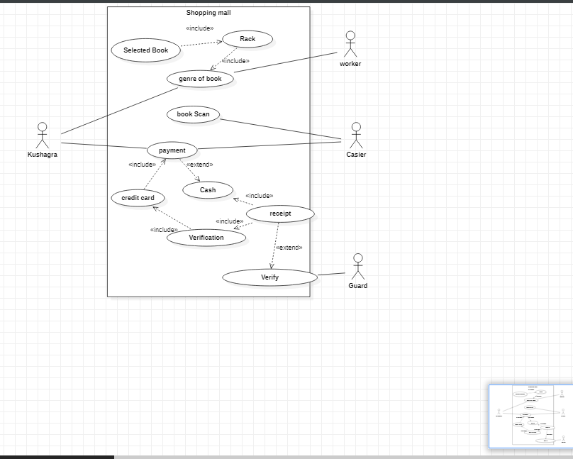

Note =>

Also, there can be many cases for the same scenario. It depends on you how you think to make it

more functional.

Like [Receipt can also be directly provide to the guard and after verification customer can exit]

a